Tunghai University Traffic Analysis

Student ID: S10920621 Name (English): JB Name (Chinese): 梅意豪

1. Introduction

Regarding Tunghai University's plan to host a significant international event with university presidents from around the world, ensuring the safety of our guests should be a priority. To guarantee a secure environment for all attendees, it is crucial to select a day when campus traffic is minimal. By leveraging data analytics and visualization skills, we will analyze Tunghai's traffic statistics, focusing on the number of cars and scooters entering the campus. The day with the lowest vehicle count will be recommended for the event, enhancing safety across the expansive Tunghai campus.

1. Data Analysis

The data used in this research is sourced from Tunghai University's Office of General Affairs website. It is important to note that the latest data available is from October 16, 2020, which may not be fully relevant for an event held in 2024. However, it is the latest reference obtainable from their official website. The data will be processed using R Studio, and the source code will be provided below, along with the reference link to the data source. Table 1 below presents the raw data of vehicles entering Tunghai's campus. Due to the vastness of the campus, Tunghai University has two entrances: the Main Gate and the Second Campus Gate.

**Table 1 shows the raw data of Tunghai University’s traffic statistics**

|  |  |  |  |  |
| --- | --- | --- | --- | --- |
| **Day** | **Vehicles** | **Main Gate** | **Second Campus's Gate** | **Total** |
| Monday | Cars | 1741 | 1628 | 3369 |
| Scooters | 1125 | 303 | 1428 |
| Tuesday | Cars | 1989 | 1728 | 3717 |
| Scooters | 1356 | 329 | 1685 |
| Wednesday | Cars | 1506 | 391 | 1897 |
| Scooters | 936 | 141 | 1077 |
| Thursday | Cars | 1866 | 1819 | 3685 |
| Scooters | 1494 | 306 | 1800 |
| Friday | Cars | 2093 | 1767 | 3860 |
| Scooters | 1369 | 361 | 1730 |
| Saturday | Cars | 805 | 440 | 1245 |
| Scooters | 169 | 54 | 223 |
| Sunday | Cars | 1149 | 247 | 1396 |
| Scooters | 220 | 35 | 255 |

1. Results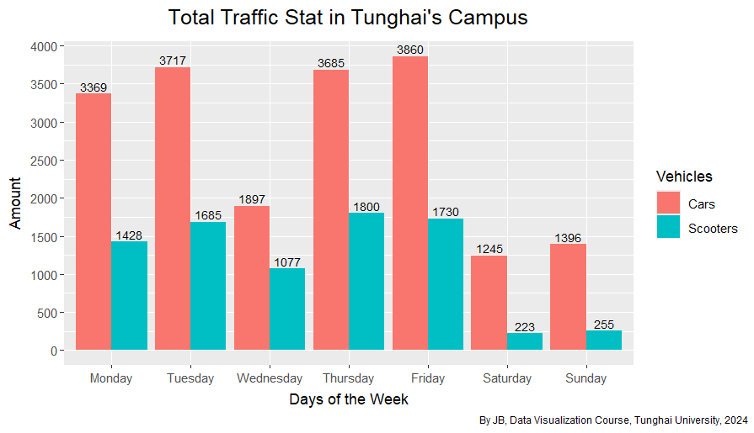

**Figure 1 shows the total incoming vehicles from the Main Gate and Second Campus**

Fig 1. displays the total incoming vehicles to Tunghai University. According to the chart, the highest number of incoming vehicles is on Friday, with 3,860 cars and 1,730 scooters. However, Thursday has the highest number of incoming scooters, totaling 1,800. The day with the lowest number of incoming vehicles is Saturday, with 1,245 cars and 223 scooters. It is evident that the number of incoming vehicles is lower on weekends compared to weekdays.

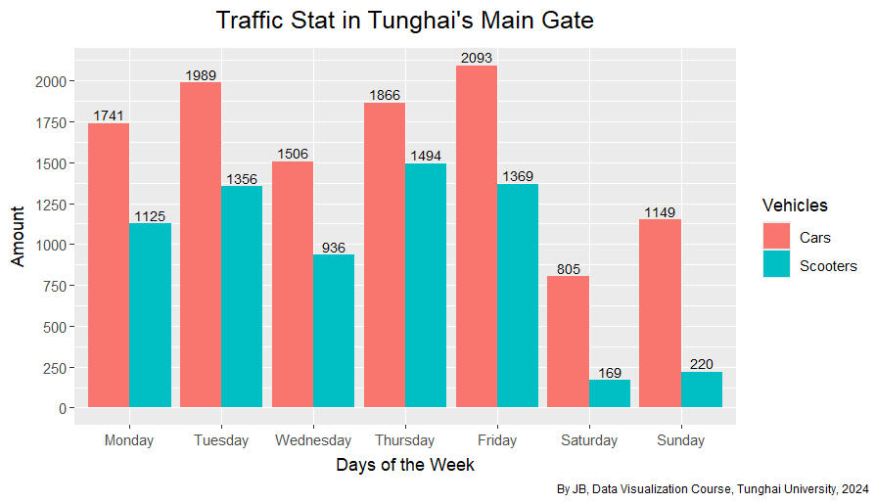

**Figure 2 shows the total incoming vehicles from the Main Gate**

Fig 2. Illustrates the incoming vehicles through the main gate. Similar to Figure 1, the highest incoming traffic occurs on Friday, with 2,093 cars and 1,369 scooters. The lowest incoming traffic through the main gate is on Saturday, with 805 cars and 169 scooters.

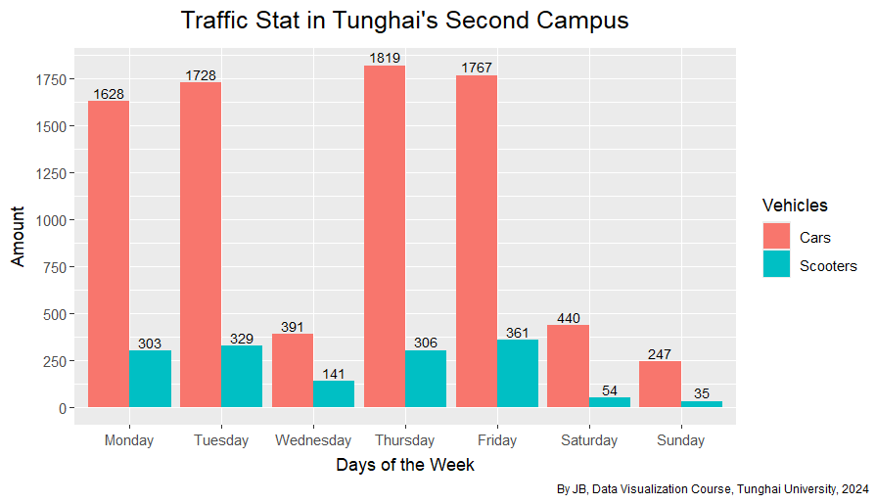

**Figure 3 shows the total incoming vehicles from the Second Campus’s Gate**

Fig 3. Shows the incoming vehicles through the second campus gate. In contrast to Figures 1 and 2, the highest incoming traffic is on Thursday, with 1,819 cars and 306 scooters. The lowest incoming traffic is on Sunday, with 247 cars and 35 scooters.

1. Conclusion

In conclusion, hosting the event on the weekend is the best option, but determining which day, Saturday or Sunday, is essential. It's important to consider that Tunghai University has its own chapel, the Luce Chapel, which holds weekly Sunday services. Since the chapel is located on the first campus, the main gate is the primary access point, explaining the higher traffic on Sundays compared to Saturdays.

Additionally, we need to determine the safest location on the Tunghai campus for the event. As shown in Figures 2 and 3, while Saturday sees the highest incoming traffic at the second campus gate on weekends, the total number of vehicles is still lower compared to the main gate. Therefore, the safest day and location to hold the event is Saturday at the Second Campus.

1. Source Code

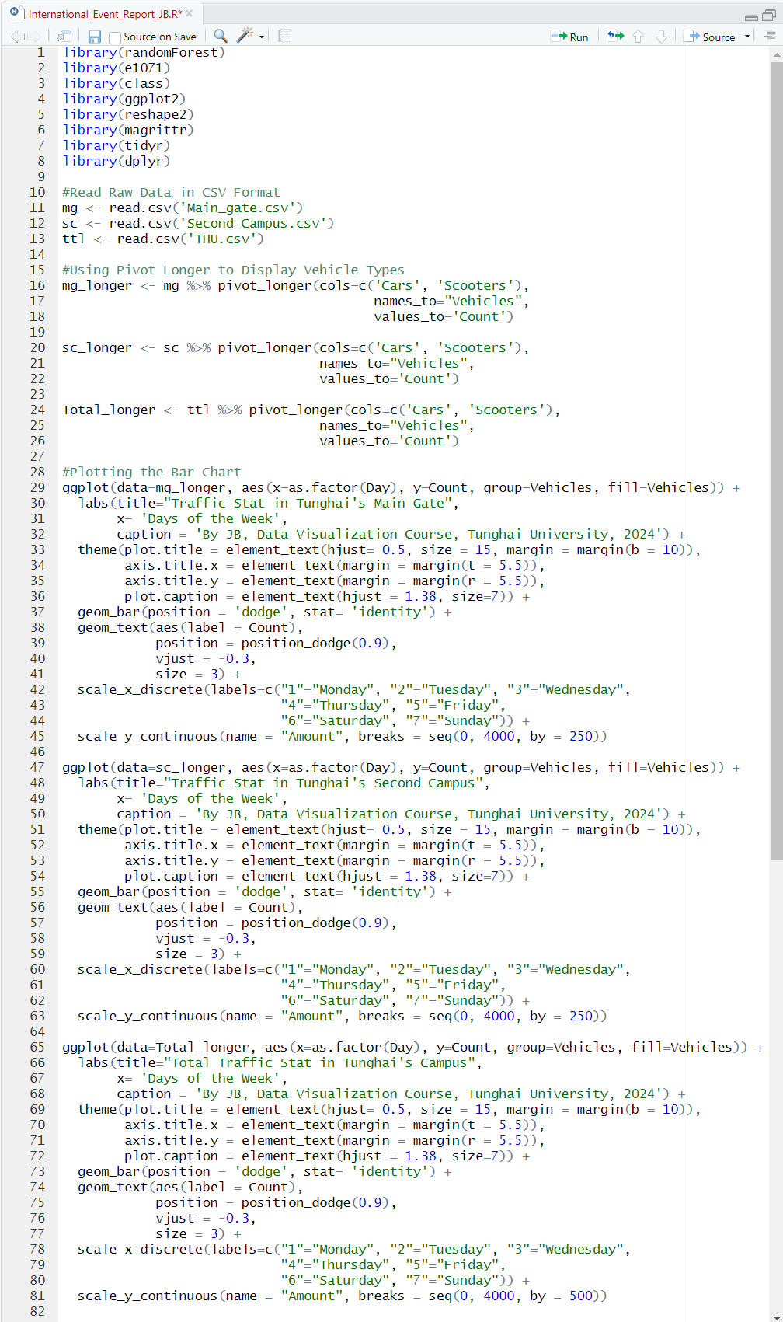Figure 4 shows the entire source code for plotting the bar chart on Fig.1, Fig. 2 and Fig.3

1. The link for the raw data provided in Table 1, and also used for the data analysis <https://general.thu.edu.tw/web/course/detail.php?id=17>